Below is a brief outline of what I will try and do, but I will make a decision based on the current circumstances at that time which some things may change, but at all times my main priority in the moment is to keep everyone safe.

Medical Emergency
Minor bumps and scratches are inevitable and I will make every effort to keep the children safe while they are in my care. Minor injuries receive appropriate first aid and if an emergency injury or illness occurs, then you will be contacted asap. If necessary, I will call the NHS service phone number on 111 for assistance and depending on what the recommend I will take your child to the nearest hospital or his or her own GP. I will then ask you to meet us there.
What three words for my home address is Croaking. Achieving. Sweat.
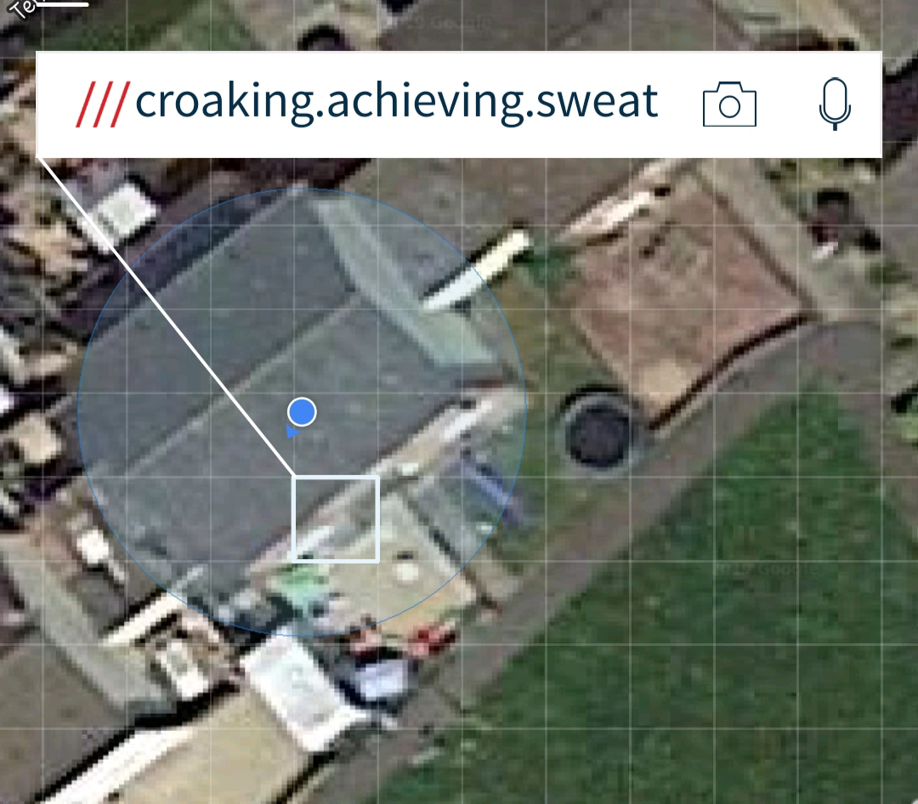 This will be given to Emergency Services so they can find me.

Accidents
I am required to record all injuries to children left in my care.
All accidents/injuries will be documented on arrival/during the day. I have a separate accident or existing injury sheet for each child. This will need to be filled in and signed by a parent/carer.

- All first aid training will be kept up to date
- The Childcare setting has a fully equipped first aid box
- Minor injuries will be dealt with at home and the parent asked to sign the accident book.

In the case of an accident requiring hospital care, I will contact the parents and the emergency services, and I will give them (what three words) for location of where we are, and try and accompany your child to the hospital, if this is possible based on who else is in my care, otherwise the paramedics will take your child to hospital without me and I will try and follow on if current circumstances allow, otherwise I will let you know they have gone on their own, I will contact my emergency member of the family, close friend or take them to the Shaftesbury Children’s Centre where they have a copy of your child record form and will contact the remaining parents of the incident that has occurred and will ask them to collect their child where they will be asked for a password. In a life-or-death situation, if the parents have not arrived, I will hand over responsibility to the medical experts.

If an accident does occur to your child whilst in my care, they will be logged in the accident book with a brief explanation of how the injury occurred and any treatment given. Your signature will then be required to say that you have been informed.

If it has been a hospitalization then I will then have to notify Ofsted at the soonest opportunity.

Under the new GDPR (General Data Protection Regulation) this information is retained until the child/children are 21yrs 3months.

